Supplementary Material
A Route-Scale Framework for Assessing Artificial Light at Night Exposure Along Migratory Bird Routes Using Tracking Data and NASA Black Marble
Ecological Informatics

Contents
Supplementary Methods S1. Habitat-level threshold and ordinal-score sensitivity
Supplementary Methods S2. Annual sensitivity of corridor-scale CEq
Tables S1-S6
Figures S1-S4
Separate Supplementary Data S1-S3 and Code S1-S2

Supplementary Methods S1. Habitat-level threshold and ordinal-score sensitivity
For each of the 18 habitat-use polygons, areas S1-S5 were extracted under three nighttime-radiance classifications while the polygon geometry, raster alignment, and area-overlay procedure were held constant. The baseline class boundaries were 0.5, 1, 5, and 10 nW cm⁻² sr⁻¹. Alternative boundaries were reduced by 20% (0.4, 0.8, 4, and 8) or increased by 20% (0.6, 1.2, 6, and 12). The ALAN-covered area was A_lit = S2 + S3 + S4 + S5. ELS was treated as undefined when A_lit = 0 and such units were excluded from conditional ELS comparisons.
The baseline normalized ordinal score vector was u = (0, 0.25, 0.50, 0.75, 1.00), equivalent to the original scores (0, 1, 2, 3, 4) after division by four. Sensitivity to the spacing of the scores was evaluated with a concave function u^0.5, the linear baseline u, and a convex function u^2. The same score vector was used for STDHNLPI and ELS. The three threshold schemes and three score functions yielded nine deterministic scenarios.
Robustness was summarized using Spearman rank correlation with the baseline, overlap among the five highest-STDHNLPI habitat-use units, and maximum absolute rank shift. Key-versus-temporary stopover contrasts were evaluated with exact label-permutation Mann-Whitney U tests because sample sizes were small and tied observations were common. Rank-biserial correlation was reported as an effect size; Benjamini-Hochberg adjustment was applied to the four baseline core-metric tests. Internal convergence checks compared STDHNLPI with continuous mean radiance, ELS with mean radiance in the ALAN-covered portion, and HER with P90 and P95. These comparisons are based on the same VNP46A4 source and are not independent field validation.

Supplementary Methods S2. Annual sensitivity of corridor-scale CEq
Corridor boundaries, migration-intensity weights, raster-processing settings, and the CEq formula were held constant, and CEq was recalculated using the 2022, 2023, and 2024 VNP46A4 annual composites. For each year, CEq was summarized for the nested 50%, 75%, and 95% corridors. Annual robustness was evaluated using corridor-specific means, standard deviations, coefficients of variation, the ratios CEq75/CEq50 and CEq95/CEq50, consistency of the 50% > 75% > 95% ordering, and pairwise similarity of the normalized annual profiles. Because the corridors were nested and only three annual composites were available, the analysis emphasized effect magnitude and ordering rather than independent-sample null-hypothesis tests.

Table S1. Alternative threshold and ordinal-score schemes
Analysis component | Scheme | Boundaries or normalized score vector | Interpretation
Threshold | Cm20 | 0.4, 0.8, 4, 8 nW cm⁻² sr⁻¹ | All four baseline boundaries reduced by 20%
Threshold | C0 | 0.5, 1, 5, 10 nW cm⁻² sr⁻¹ | Baseline radiance classification
Threshold | Cp20 | 0.6, 1.2, 6, 12 nW cm⁻² sr⁻¹ | All four baseline boundaries increased by 20%
Score | Concave, γ=0.5 | (0, 0.500, 0.707, 0.866, 1) | Greater relative emphasis on low-radiance classes
Score | Linear, γ=1 | (0, 0.250, 0.500, 0.750, 1) | Baseline equal-interval ordinal scoring
Score | Convex, γ=2 | (0, 0.0625, 0.250, 0.5625, 1) | Greater relative emphasis on high-radiance classes

Table S2. Threshold sensitivity of habitat-exposure metrics
Metric | Alternative | N | Spearman ρ | Bootstrap 95% CI | Mean |Δ| | Maximum |Δ| | Maximum rank shift | Top-five overlap
PCR | Cm20 | 18 | 1.000 | 1.000-1.000 | 0.0000 | 0.0000 | 0.0 | 5/5
PCR | Cp20 | 18 | 0.982 | 0.907-1.000 | 0.0399 | 0.2314 | 2.0 | 4/5
STDHNLPI | Cm20 | 18 | 1.000 | 1.000-1.000 | 0.0051 | 0.0349 | 0.0 | 5/5
STDHNLPI | Cp20 | 18 | 0.989 | 0.935-1.000 | 0.0131 | 0.0702 | 2.0 | 5/5
ELS | Cm20 | 12 | 0.909 | 0.631-1.000 | 0.0192 | 0.0382 | 3.0 | 4/5
ELS | Cp20 | 12 | 0.878 | 0.557-1.000 | 0.0110 | 0.0357 | 4.5 | 4/5
HER | Cm20 | 18 | 0.995 | 0.959-1.000 | 0.0048 | 0.0697 | 1.0 | 5/5
HER | Cp20 | 18 | 0.995 | 0.956-1.000 | 0.0023 | 0.0349 | 1.0 | 5/5

Note: ELS analyses included only the 12 habitat-use units with detectable ALAN coverage under both compared schemes. Top-five overlap refers to the metric-specific five highest units.

Table S3. Exact key-versus-temporary stopover comparisons across threshold schemes
Scenario | Metric | N key | N temporary | Median key | Median temporary | Exact permutation p | Rank-biserial r | BH q (baseline)
Cm20 | PCR | 6 | 10 | 0.1075 | 0.0047 | 0.0141 | 0.733
Cm20 | STDHNLPI | 6 | 10 | 0.0288 | 0.0014 | 0.0207 | 0.700
Cm20 | ELS | 6 | 5 | 0.2954 | 0.2857 | 0.5628 | 0.233
Cm20 | HER | 6 | 10 | 0.0000 | 0.0000 | 0.7500 | 0.083
C0 | PCR | 6 | 10 | 0.1075 | 0.0047 | 0.0141 | 0.733 | 0.0415
C0 | STDHNLPI | 6 | 10 | 0.0276 | 0.0014 | 0.0207 | 0.700 | 0.0415
C0 | ELS | 6 | 5 | 0.2700 | 0.2500 | 0.4459 | 0.300 | 0.5945
C0 | HER | 6 | 10 | 0.0000 | 0.0000 | 0.7500 | 0.083 | 0.7500
Cp20 | PCR | 6 | 10 | 0.0346 | 0.0020 | 0.0287 | 0.667
Cp20 | STDHNLPI | 6 | 10 | 0.0092 | 0.0005 | 0.0287 | 0.667
Cp20 | ELS | 6 | 5 | 0.2692 | 0.2500 | 0.2749 | 0.400
Cp20 | HER | 6 | 10 | 0.0000 | 0.0000 | 0.7500 | 0.083

Note: ELS excluded units with A_lit = 0; consequently, ELS comparisons used six key and five temporary stopover units. Positive rank-biserial values indicate higher values at key stopovers.

Table S4. STDHNLPI robustness across the nine threshold-by-score scenarios
Threshold | Score scheme | Spearman ρ vs baseline | Maximum rank shift | Top-five overlap | Mean |Δ| | Maximum |Δ|
Cm20 | Concave γ=0.5 | 0.998 | 1.0 | 4/5 | 0.0445 | 0.2667
Cm20 | Linear γ=1 | 1.000 | 0.0 | 5/5 | 0.0051 | 0.0349
Cm20 | Convex γ=2 | 0.994 | 1.0 | 5/5 | 0.0325 | 0.2009
C0 | Concave γ=0.5 | 0.998 | 1.0 | 4/5 | 0.0406 | 0.2461
C0 | Linear γ=1 | 1.000 | 0.0 | 5/5 | 0.0000 | 0.0000
C0 | Convex γ=2 | 0.996 | 1.0 | 5/5 | 0.0372 | 0.2404
Cp20 | Concave γ=0.5 | 0.989 | 2.0 | 5/5 | 0.0226 | 0.1839
Cp20 | Linear γ=1 | 0.989 | 2.0 | 5/5 | 0.0131 | 0.0702
Cp20 | Convex γ=2 | 0.987 | 2.0 | 5/5 | 0.0423 | 0.2626

The baseline is C0 with the linear score vector. Across all nine scenarios, the minimum STDHNLPI rank correlation was 0.987, at least four of the baseline top five units were retained, and the maximum rank shift was two positions.

Table S5. Internal convergence checks
Comparison | N | Spearman ρ | Bootstrap 95% CI | Permutation p | Kendall τ-b
STDHNLPI vs MeanRadiance | 18 | 0.998 | 0.968-1.000 | 0.00001 | 0.986
ELS vs MeanExposed | 12 | 0.890 | 0.558-0.993 | 0.00031 | 0.763
HER vs P90 | 18 | 0.493 | -0.158-0.896 | 0.02321 | 0.467
HER vs P95 | 18 | 0.678 | 0.406-0.892 | 0.00184 | 0.611

These are same-source convergence checks derived from VNP46A4, not independent ecological validation.

Table S6. Annual sensitivity of probability-weighted corridor exposure (CEq)
Year/statistic | 50% CEq | 75% CEq | 95% CEq | 75%/50% | 95%/50%
2022 | 1.0771 | 0.9301 | 0.9109 | 0.8636 | 0.8458
2023 | 1.1667 | 1.0171 | 0.9840 | 0.8718 | 0.8434
2024 | 1.1507 | 0.9988 | 0.9728 | 0.8680 | 0.8454
Three-year mean | 1.1315 | 0.9820 | 0.9559 | 0.8678 | 0.8449
Annual CV (%) | 4.23 | 4.67 | 4.12 | 0.470 | 0.149

All three annual composites retained the 50% > 75% > 95% ordering (Kendall's W = 1.000). CEq units are nW cm⁻² sr⁻¹; ratios are dimensionless.

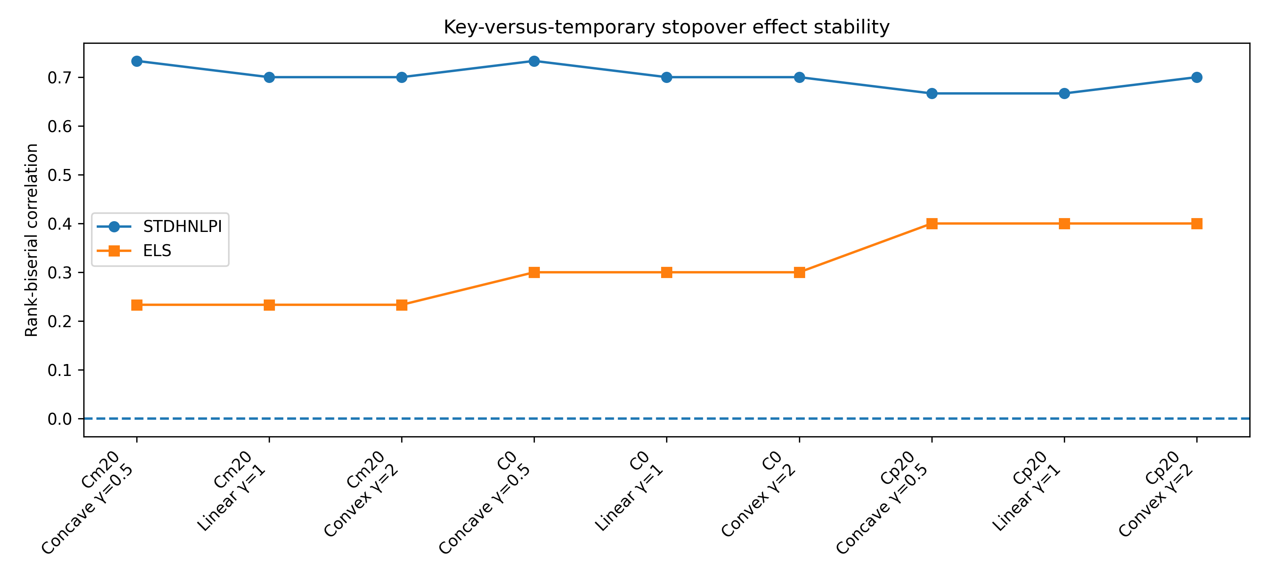
Figure S1. Stability of key-versus-temporary stopover effect sizes across the nine threshold-by-score scenarios. Rank-biserial correlation remained positive for STDHNLPI in every scenario, whereas conditional ELS effects were smaller and not statistically clear.

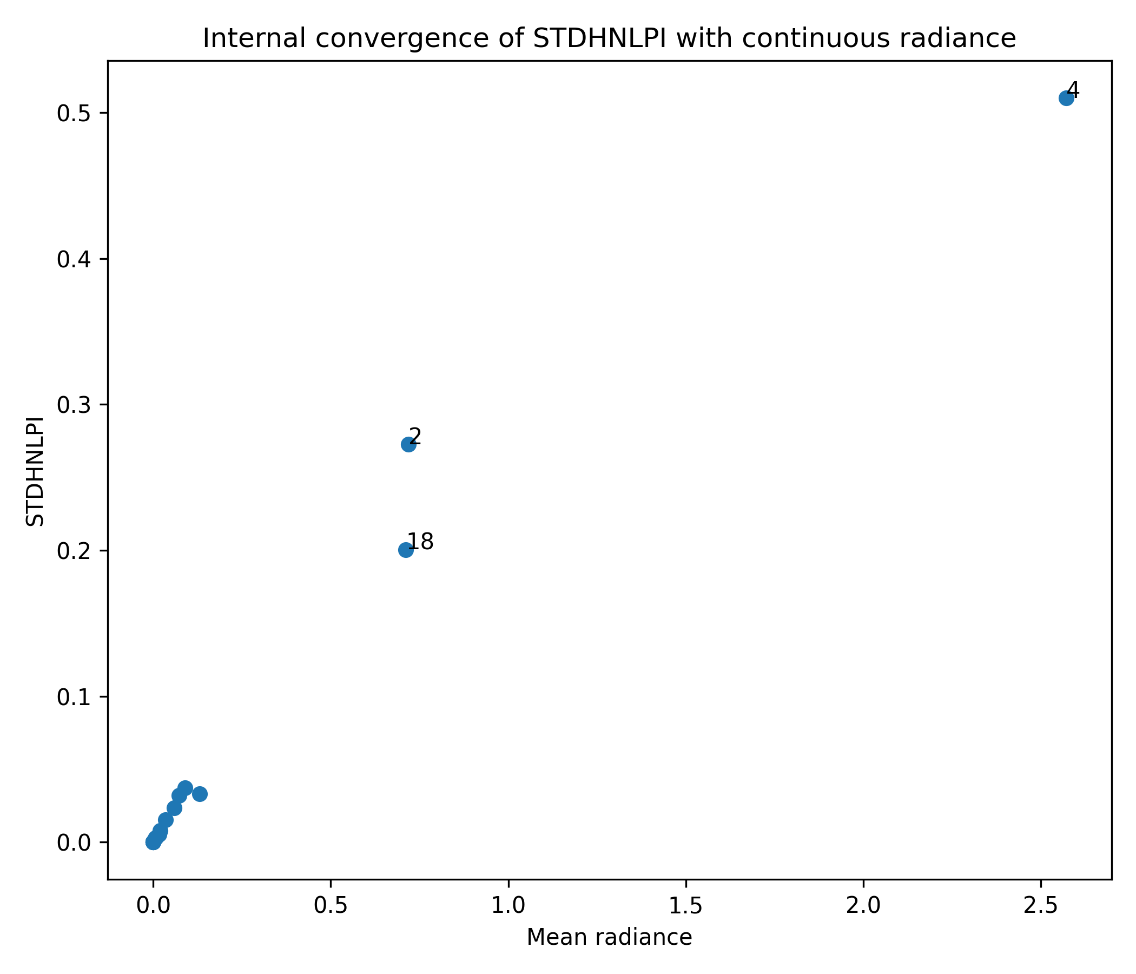
Figure S2. Internal convergence between baseline STDHNLPI and continuous mean radiance. Labels identify the highest-exposure habitat-use units.

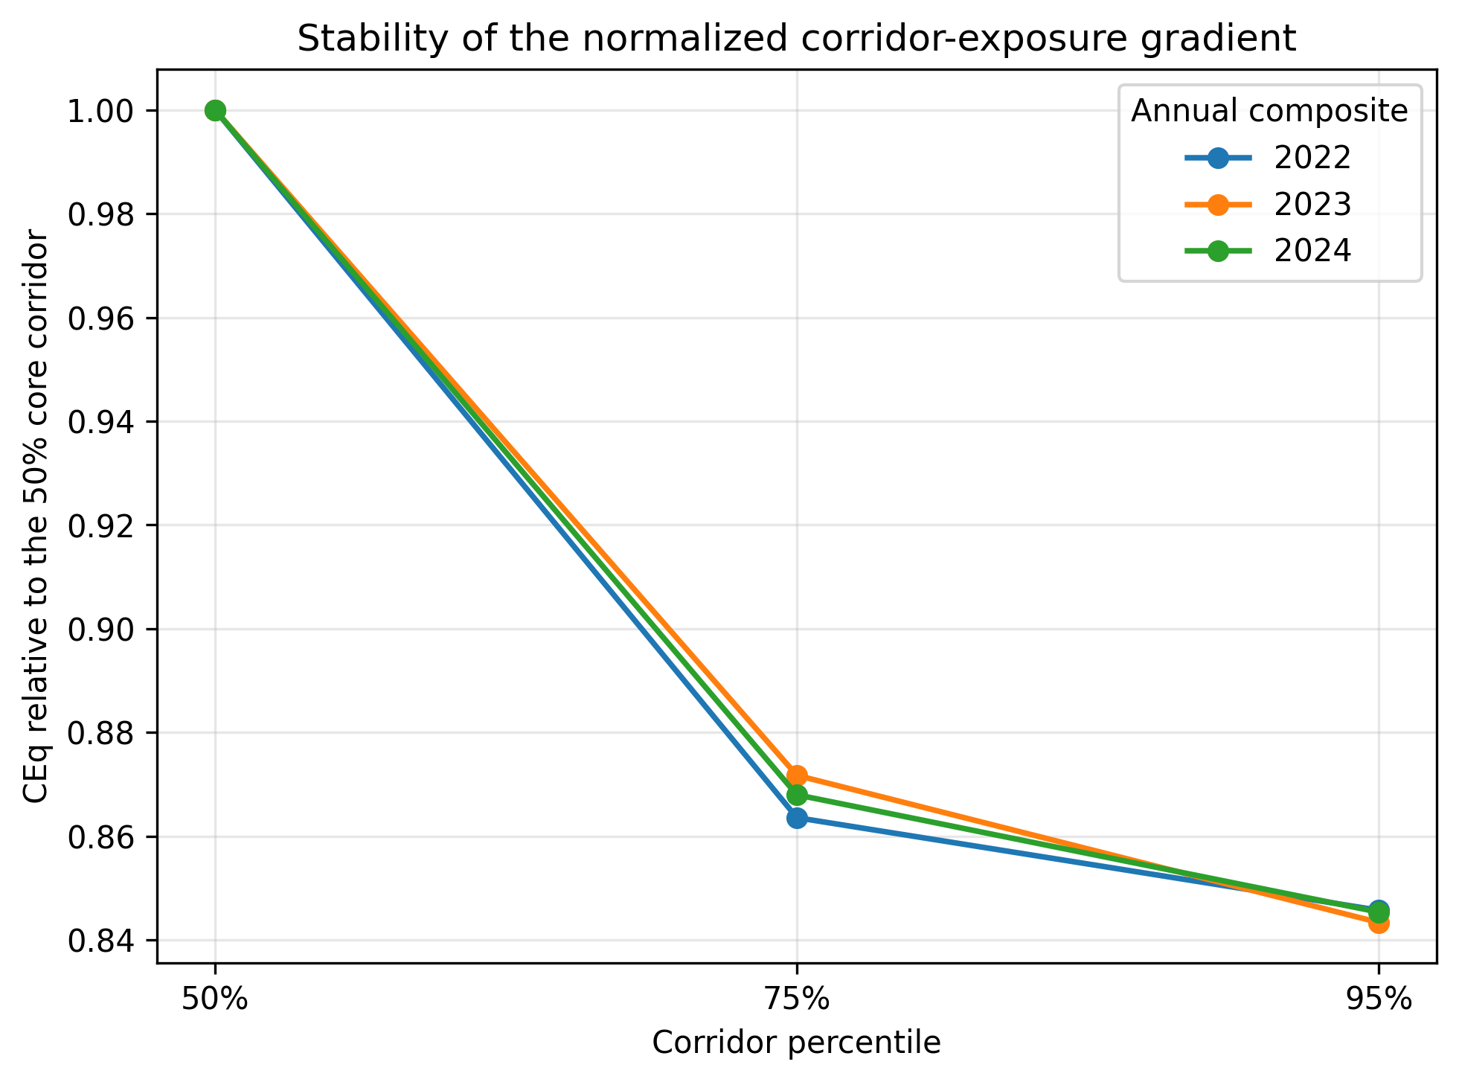
Figure S3. Annual stability of the corridor-exposure gradient after normalizing CEq to the 50% core corridor within each year.

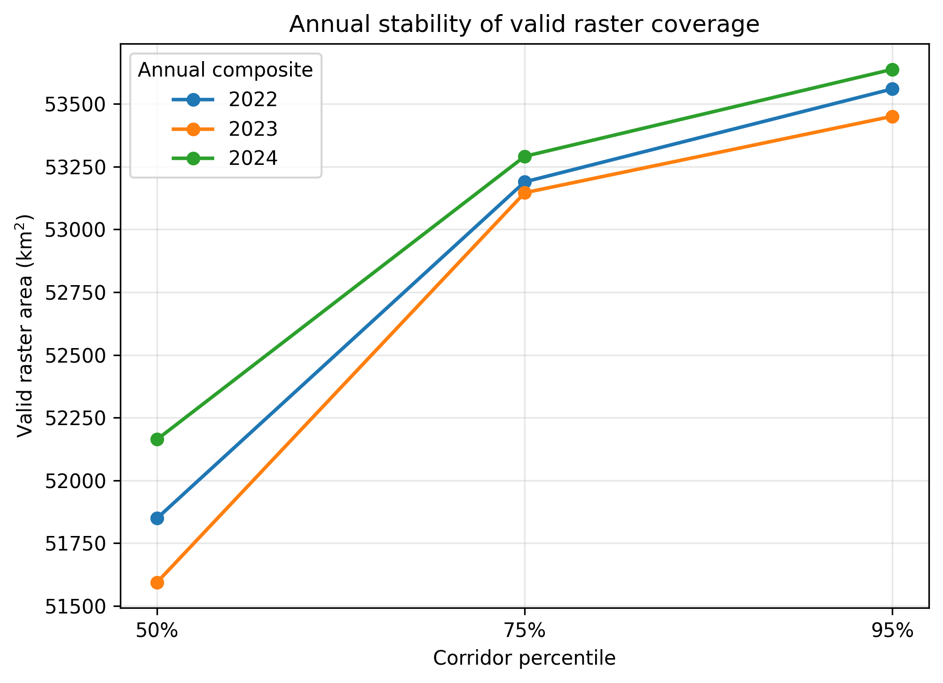
Figure S4. Valid VNP46A4 raster area within the nested corridors for the 2022-2024 annual composites.

Separate supplementary data and code files
Designation | File name | Purpose
Supplementary Data S1 | Data_S1_Habitat_Class_Areas.csv | Class-specific areas S1-S5 for all 18 habitat-use units under Cm20, C0, and Cp20 thresholds.
Supplementary Data S2 | Data_S2_Habitat_Exposure_Metrics.csv | Corrected habitat metrics and continuous-radiance summaries; ELS is missing when A_lit = 0.
Supplementary Data S3 | Data_S3_CEq_Annual_Sensitivity.csv | Annual CEq, valid raster area, and cell counts for the 50%, 75%, and 95% corridors in 2022-2024.
Supplementary Code S1 | Code_S1_Habitat_Robustness.py | Reproduces threshold sensitivity, ordinal-score sensitivity, exact stopover comparisons, and convergence summaries.
Supplementary Code S2 | Code_S2_CEq_Annual_Sensitivity.py | Reproduces the annual CEq sensitivity tables and annual/normalized profiles.

